**Selenium Grid – Hub & Node Setup in any remote system (Windows)**

**Steps**:

1. Go to the remote system where automation is expected to trigger.
2. Make sure java is installed in that system. If not, download and install it from <https://www.java.com/en/download/>
3. Download selenium standalone jar from below location (take care of the version)

<http://selenium-release.storage.googleapis.com/2.53/selenium-server-standalone-2.53.1.jar>

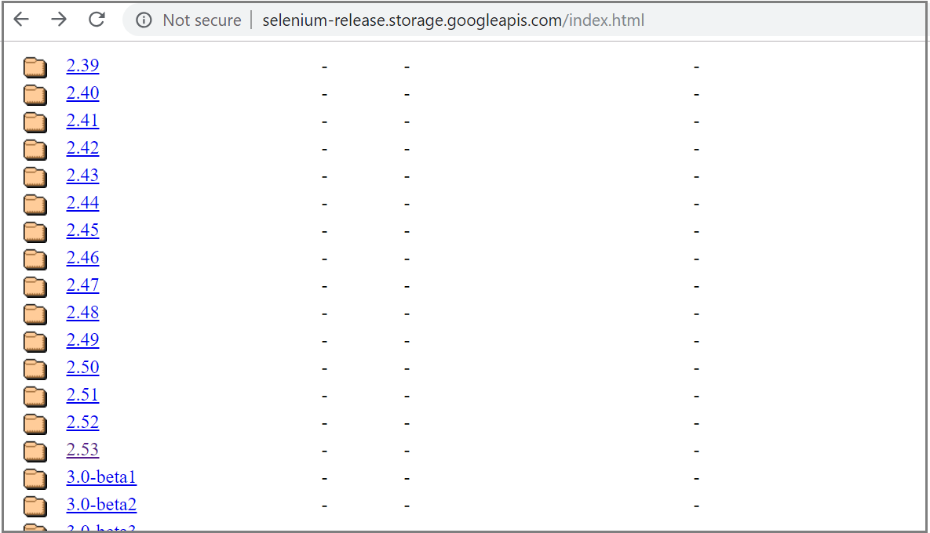

Select required version.

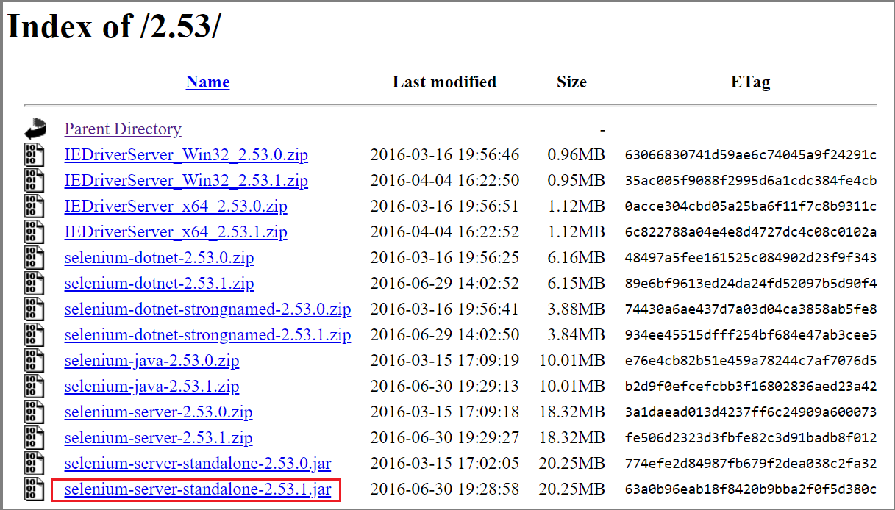

1. Now, open 2 command prompt windows and navigate to the path where the above jar is downloaded.
2. In the first cmd window, run below command –

**java -jar selenium-server-standalone-2.53.1.jar -role hub -port 4442**

After running above command, below is the output

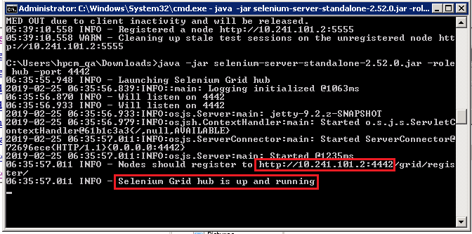

1. From above output, note the ip address high-lighted.
2. In the second cmd window, run below command –

**java -jar selenium-server-standalone-2.53.1.jar -role node -hub http:// 10.241.101.2:4442/grid/register**

After running above command, below is the output

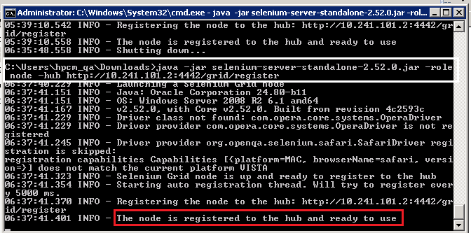

1. Now, give the hub url in this format – http://<systemName>.us.oracle.com:4442/wd/hub

Eg: hubUrl="http://slc15dwa.us.oracle.com:4442/wd/hub"

Here, we should pass hubUrl (any variable) value from Jenkins.

If we need to run the scripts on Firefox browser, here is the piece of code –

*capabilities=new DesiredCapabilities();*

*if (driver == null) {*

*URL hubUrl = null;*

*if (hubUrl == null) {*

*hubUrl = new URL(hubUrl);*

*}*

*capabilities.setBrowserName("firefox");*

*capabilities.setPlatform(Platform.VISTA);*

*try {*

*driver = new RemoteWebDriver(hubUrl, capabilities);*

*} catch (Exception e) {*

*e.printStackTrace();*

*}*

*}*